1. Conifers have vascular tissue.
*a. true
b. false

2. On the diagram of a conifer below, the structures labeled "a" are the
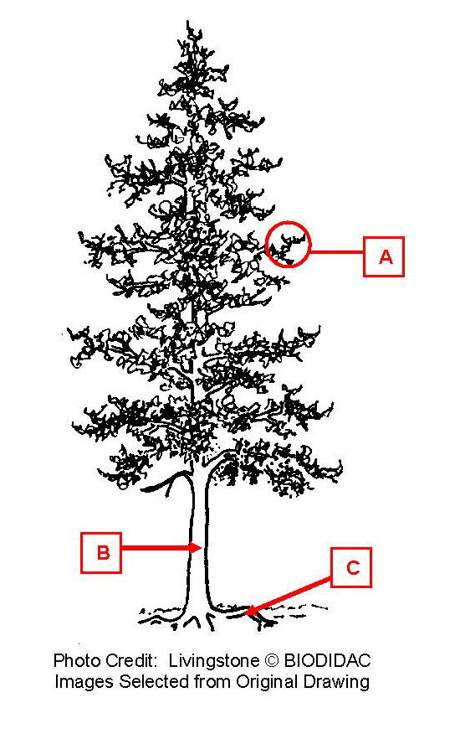

a. gametophyte
*b. leaves
c. roots
d. sporophyte
e. stem

3. On the diagram of a conifer below, the structure labeled "b" is the

a. gametophyte
b. leaves
c. roots
d. sporophyte
*e. stem

4. On the diagram of a conifer below, the structures labeled "c" are the

a. gametophyte
b. leaves
*c. roots
d. sporophyte
e. stem

5. On the diagram of a conifer below, this is which generation?

a. gametophyte
b. leaves
c. roots
*d. sporophyte
e. stem

6. On the diagram of a conifer branch below, the structure labeled "a" is a
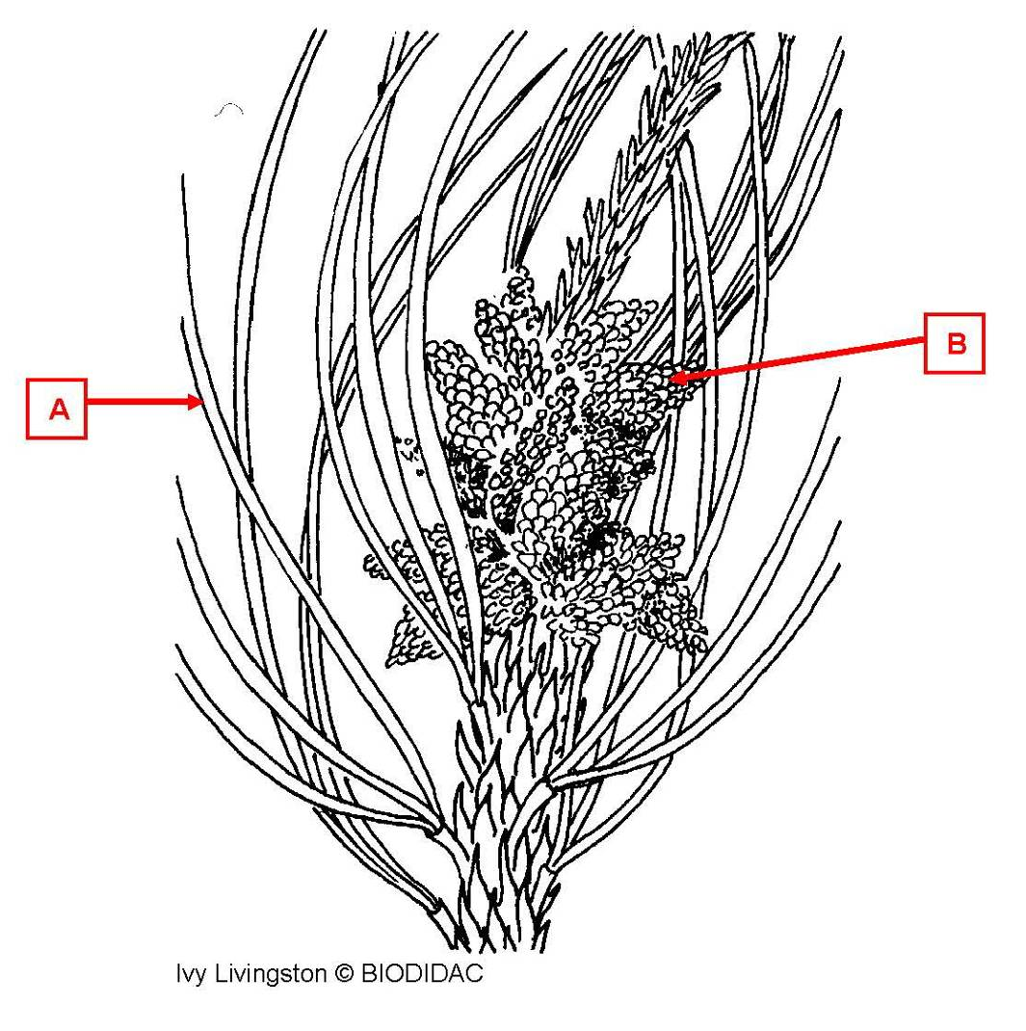

a. pollen cone (strobilus)
b. seed cone (strobilus)
*c. vegetative leaf

7. On the diagram of a conifer branch below, the structure labeled "b" is a

*a. pollen cone (strobilus)
b. seed cone (strobilus)
c. vegetative leaf

8. On the diagram of a conifer branch below, the structure labeled "a" is a
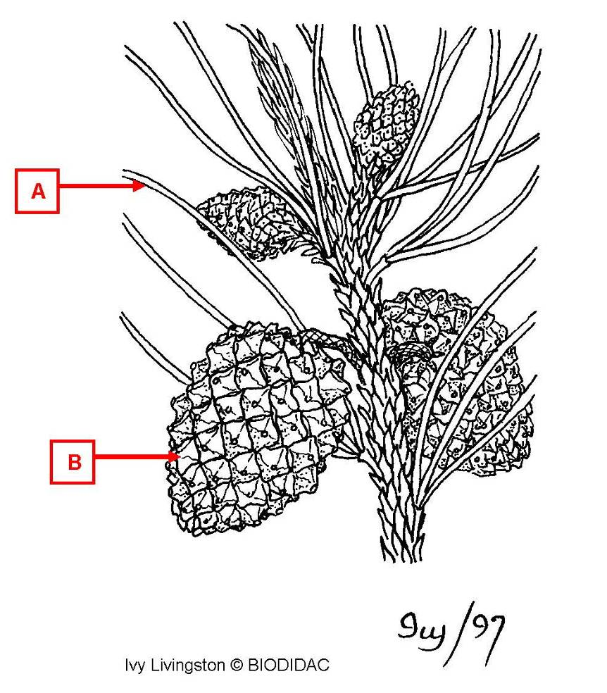

a. pollen cone (strobilus)
b. seed cone (strobilus)
*c. vegetative leaf

9. On the diagram of a conifer branch below, the structure labeled "b" is a

a. pollen cone (strobilus)
*b. seed cone (strobilus)
c. vegetative leaf

10. On the diagram showing the stages of development of an ovulate cone, the
structure labeled "a" is a/an
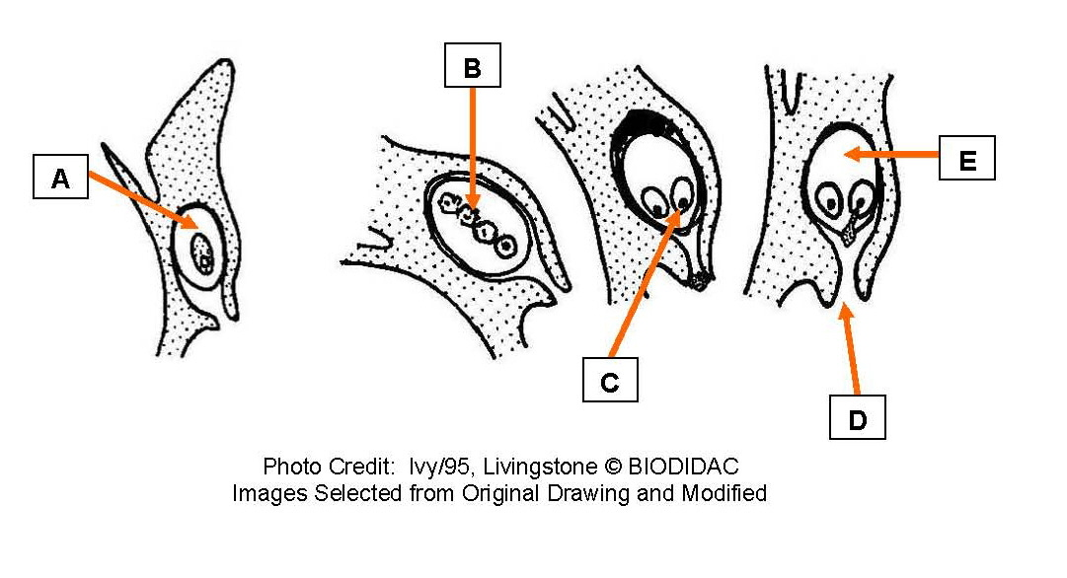

a. egg
b. female gametophyte
*c. megasporangium
d. megaspore
e. micropyle

11. On the diagram showing the stages of development of an ovulate cone, the
structure labeled "b" is a/an

a. egg
b. female gametophyte
c. megasporangium
*d. megaspore
e. micropyle

12. On the diagram showing the stages of development of an ovulate cone, the
structure labeled "c" is a/an

*a. egg
b. female gametophyte
c. megasporangium
d. megaspore
e. micropyle

13. On the diagram showing the stages of development of an ovulate cone, the
structure labeled "d" is a/an

a. egg
b. female gametophyte
c. megasporangium
d. megaspore
*e. micropyle

14. On the diagram showing the stages of development of an ovulate cone, the
structure labeled "e" is a/an

a. egg
*b. female gametophyte
c. megasporangium
d. megaspore
e. micropyle

15. On the diagram of a pollen cone below, the structure labeled "a" is the
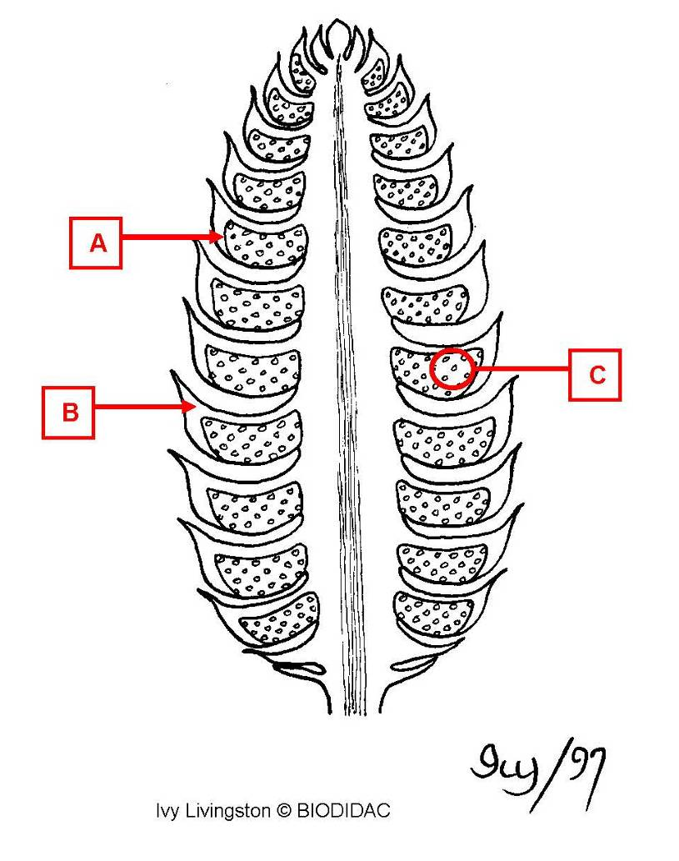

*a. microsporangium
b. microspores
c. microsporophyll
d. pollen grain

16. On the diagram of a pollen cone below, the structure labeled "b" is the

a. microsporangium
b. microspores
*c. microsporophyll
d. pollen grain

17. On the diagram of a pollen cone below, the structure labeled "c" contains the

a. microsporangium
*b. microspores
c. microsporophyll
d. pollen grain

18. On the diagram of a pollen cone, the circled structure is a
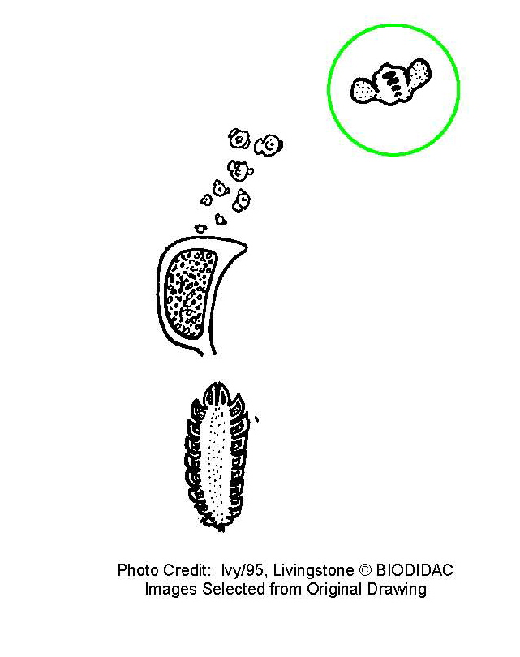

a. microsporangium
b. microspores
c. microsporophyll
*d. pollen grain

19. On the diagram of a conifer ovule, the structure labeled "a" is the
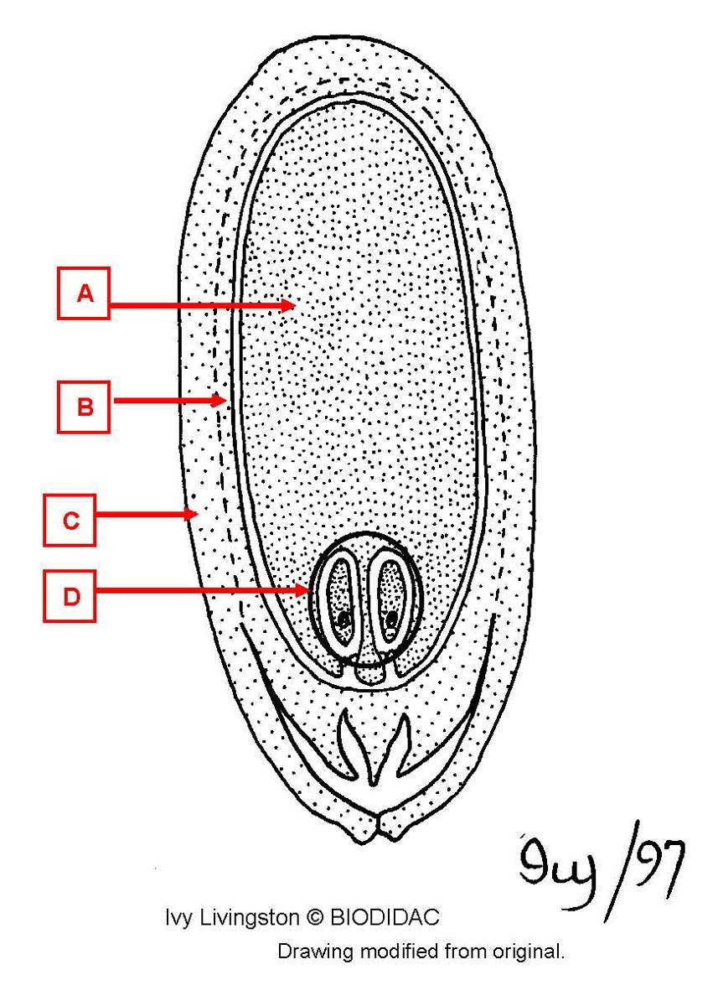

a. eggs
*b. female gametophyte
c. integument
d. megasporangium

20. On the diagram of a conifer ovule, the structure labeled "b" is the

a. eggs
b. female gametophyte
c. integument
*d. megasporangium

21. On the diagram of a conifer ovule, the structure labeled "c" is the

a. eggs
b. female gametophyte
*c. integument
d. megasporangium

22. On the diagram of a conifer ovule, the structure labeled "d" is the

*a. eggs
b. female gametophyte
c. integument
d. megasporangium

23. On the diagram of a conifer seedling, the structure labeled "a" is the
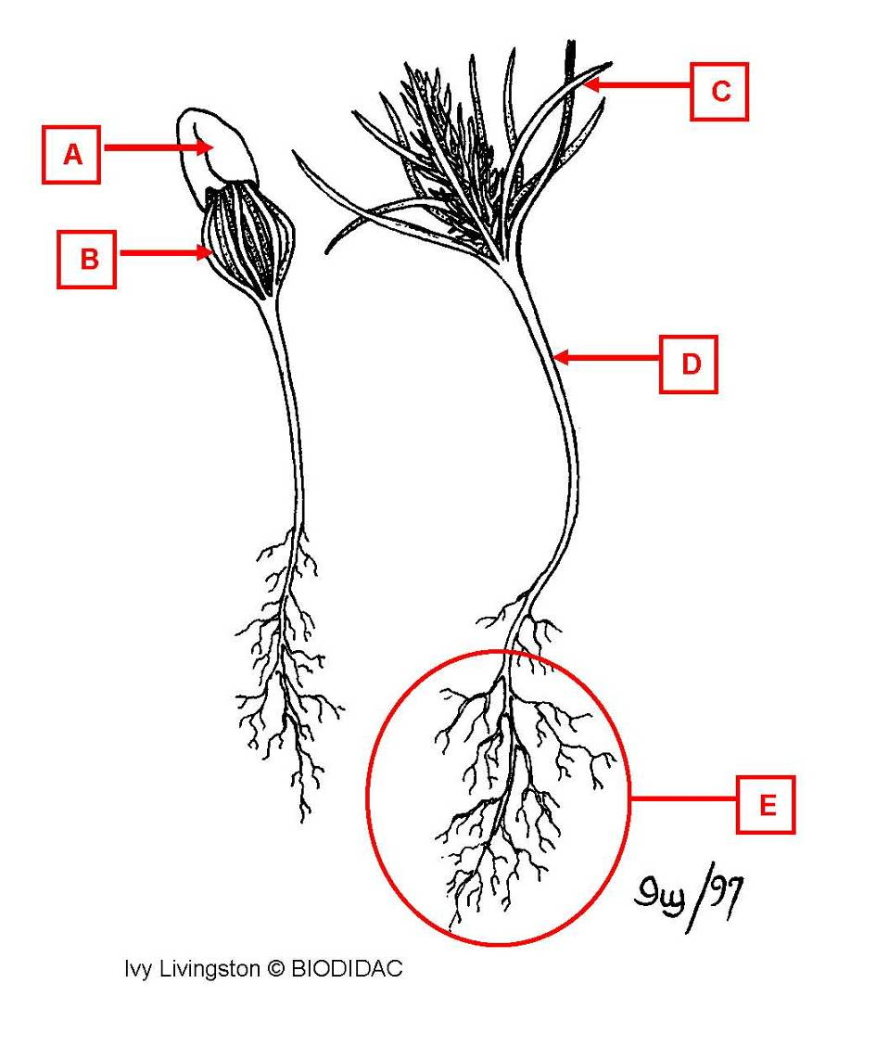

a. cotyledon
b. leaf
c. roots
*d. seed coat
e. stem

24. On the diagram of a conifer seedling, the structure labeled "b" is the

*a. cotyledon
b. leaf
c. roots
d. seed coat
e. stem

25. On the diagram of a conifer seedling, the structure labeled "c" is the

a. cotyledon
*b. leaf
c. roots
d. seed coat
e. stem

26. On the diagram of a conifer seedling, the structure labeled "d" is the

a. cotyledon
b. leaf
c. roots
d. seed coat
*e. stem

27. On the diagram of a conifer seedling, the structure labeled "e" is the

a. cotyledon
b. leaf
*c. roots
d. seed coat
e. stem

28. On the diagram of a conifer seedling, the plant on the right is a

a. gametophyte
*b. sporophyte

